ITD – ITIN Power Apps Training · Student Lab Guide
Lab 04: Build the My Team View
Management Workforce Availability App — search, filter, and at-a-glance status
Estimated time | 50–65 minutes
Difficulty | Beginner – Intermediate (your first lab combining several filters)
Prerequisite | Lab 00 through Lab 03 completed
You will build | A search box, three filters, and colored status indicators on the My Team gallery

Lab Overview
The My Team gallery from Lab 02 currently shows every record in the list. In this lab you'll help managers actually use it: searching by name, filtering by date, status, and team, and spotting availability at a glance with color.

Objectives
- Build on the team availability gallery from Lab 02.
- Add a search field.
- Filter by work date.
- Filter by availability status.
- Filter by team or unit.
- Add visual status indicators.
ℹ NOTE
The lab exercises refer to the employee-name field as “EmployeeName.” Because Lab 00 kept SharePoint's built-in Title column for that data, every formula in this guide uses Title where the original exercise text says EmployeeName — they are the same field.

Power Apps concepts used in this lab
Concept |  | What it means
Filter() |  | Returns only the records from a data source that match one or more conditions.
SortByColumns() |  | Returns records in a chosen order (e.g., alphabetically by name).
“in” operator |  | Checks whether one piece of text appears inside another — used for search-as-you-type.
Distinct() |  | Returns each unique value found in a column, useful for building a filter dropdown.
Switch() |  | Picks one result out of several, based on matching a value — used here to pick a color.
💡 TIP
As your list of records grows into the hundreds, some formulas here may show a small blue delegation warning triangle. For this training-sized list (a handful of fictitious records) you can safely ignore it — it becomes relevant only with much larger, real data sources.

Part A — Add the Search Box
- In the Tree view, click “My Team or the screen which is empty” to select that screen.
- Click the “Insert” tab,
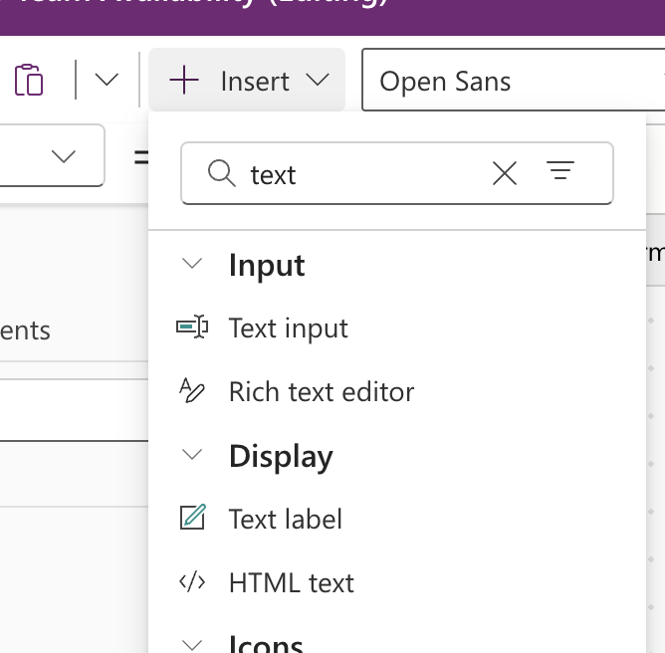
then “Text input,” and place it above the gallery.
- Rename it
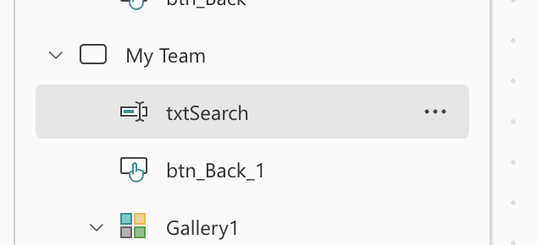
- (name box above the canvas) to:
txtSearch
- In the Properties pane on the right,
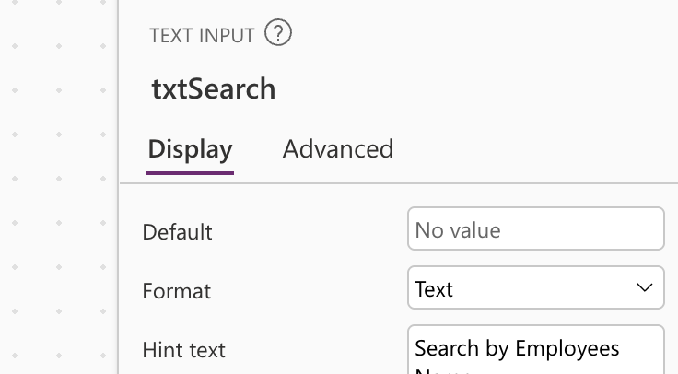
- find HintText and set it to
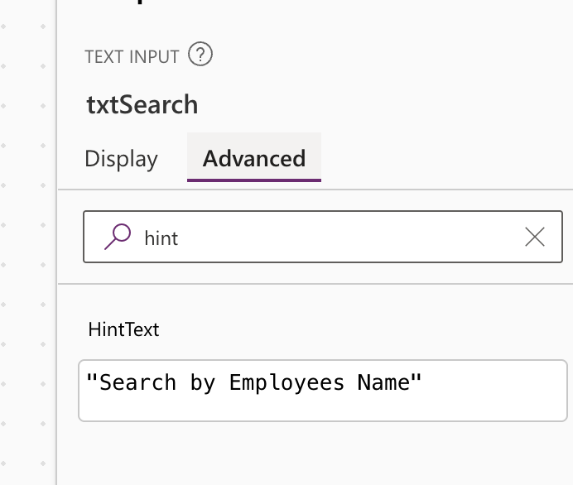
- Search by employee name… so users know what the box is for.

Part B — Add the Work Date Filter
- Click the “Insert” tab, then “Date picker,”
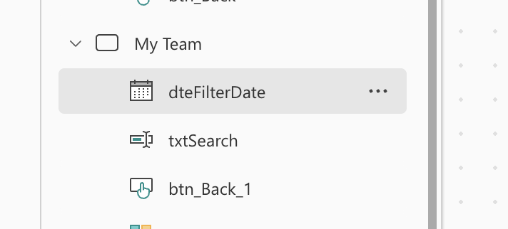
- and place it next to the search box.
- Rename it to:
dteFilterDate
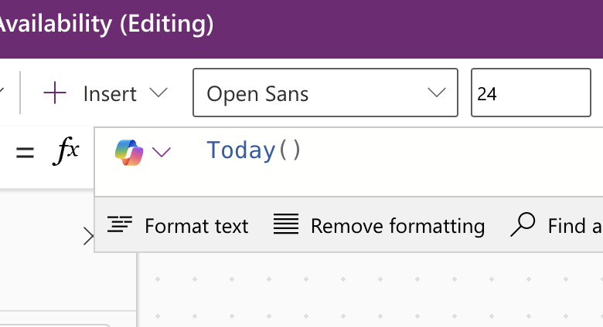
- In the formula bar, set its Default property to:
Today()
⚠ IMPORTANT
The filter formula you'll add in Part E requires an exact date match, so the gallery will look empty unless dteFilterDate is set to a date that has records. Your Lab 00 sample records all use 23 September 2026 — select that date while testing in Part G.

Part C — Add the Availability Status Filter
- Click the “Insert” tab
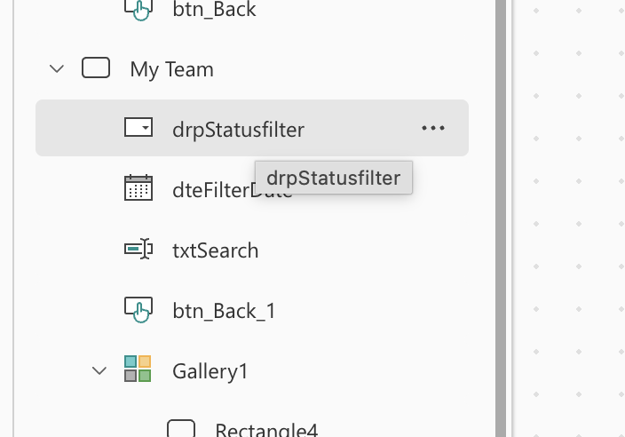
- , then “Drop down,” and place it next to the date picker.
- Rename it to:
drpStatusFilter
- Select it, then in the formula
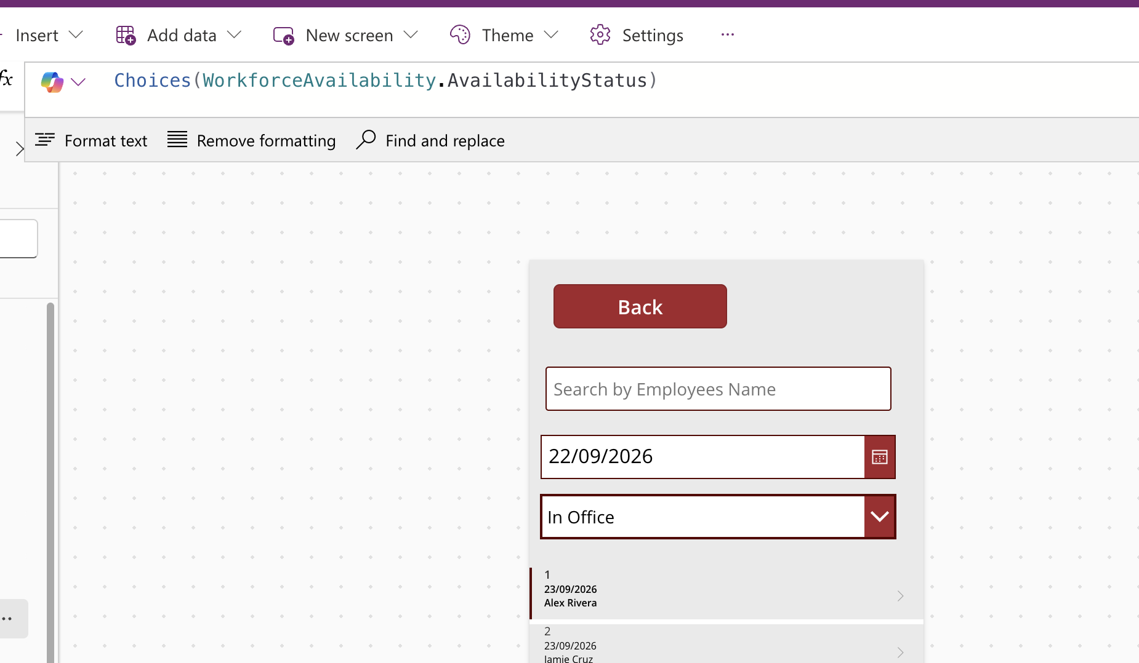
- bar set its Items property to:
Choices(WorkforceAvailability.AvailabilityStatus)
ℹ NOTE
Choices() reads the valid options directly from your Choice column, so the six status values from Lab 00 (In Office, Working from Home, etc.) will appear automatically — you don't have to type them again.

Part D — Add the Team or Unit Filter
- Click the “Insert” tab, then “Drop down,” and place it next to the status filter.
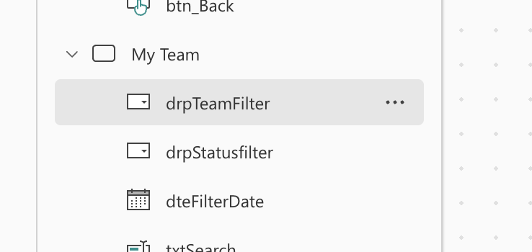
- Rename it to:
drpTeamFilter
- Select it, then set its Items property to:
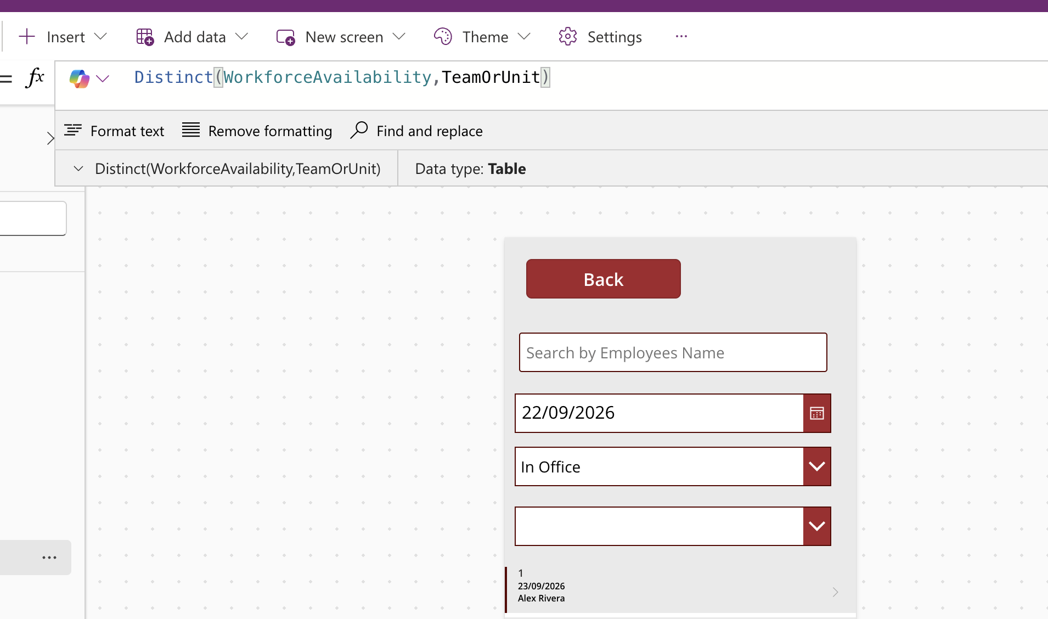
Distinct(WorkforceAvailability, TeamOrUnit)
ℹ NOTE
Distinct() has a different shape than Choices(): its results use a field called Result rather than Value. Keep that in mind for Part E — you'll write drpTeamFilter.Selected.Result, not .Value.

Part E — Combine Everything in the Gallery
Now bring the search box and all three filters together in the gallery's Items property, replacing the simple WorkforceAvailability formula from Lab 02.
- In the Tree view, click galAvailability to select the gallery on the My Team screen.
- In the formula bar, make sure the property dropdown shows Items, then replace the existing formula with:
- SortByColumns(
- Filter(
- WorkforceAvailability,
- IsBlank(dteFilterDate.SelectedDate) || WorkDate = dteFilterDate.SelectedDate,
- IsBlank(txtSearch.Text) || txtSearch.Text in Title,
- IsBlank(drpStatusfilter.Selected.Value) ||
- AvailabilityStatus.Value = drpStatusfilter.Selected.Value
- ),
- "Title",
- SortOrder.Ascending
- )

- Press Enter to save the formula.

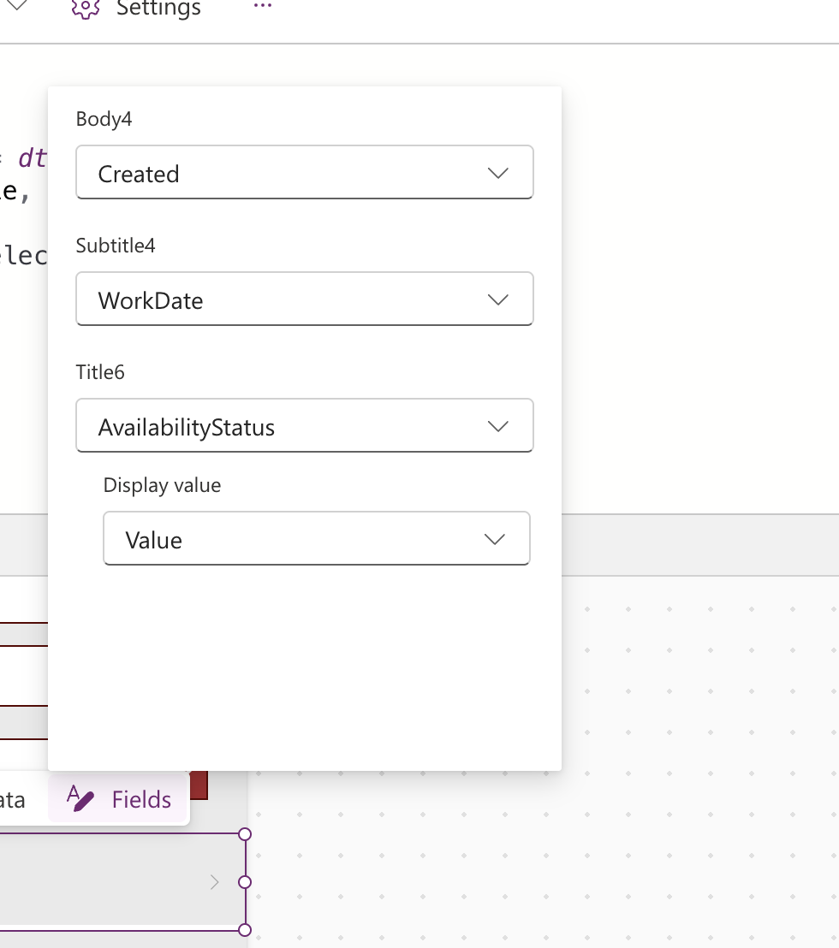

What each line is doing
Line |  | In plain language
ManagerEmail = User().Email |  | Only show records where the signed-in manager is listed as the manager.
WorkDate = dteFilterDate.SelectedDate |  | Only show records for the date currently selected.
IsBlank(txtSearch.Text) || … in Title |  | If the search box is empty, ignore it. Otherwise, only show rows where the name contains what was typed.
IsBlank(…Selected.Value) || … |  | Same pattern for the status filter — empty means “show all statuses.”
IsBlank(…Selected.Result) || … |  | Same pattern again for the team filter.
SortByColumns(…, “Title”, SortOrder.Ascending) |  | Sorts the final results alphabetically by employee name.
💡 TIP
This “IsBlank(filter) || condition” pattern — repeated three times above — is one of the most useful patterns in Power Apps: it lets a filter be optional. Notice the WorkDate line does not use this pattern, so it is always required (see the warning box in Part B).

Part G — Test Your Filters
- Click the Play button (▶), or press F5, to preview the app, and navigate to My Team.
- Exit preview (Esc) and save your app (Ctrl+S).
💡 TIP
Stretch challenge: the WorkDate filter is currently required, unlike the other three. Try applying the same IsBlank(…) || … pattern to it so managers can also choose to see every date at once.

Lab 04 Complete — Checkpoint
✅ CHECKPOINT
You should now have a My Team gallery with a working search box and three filters (date, status, team), each combinable with the others, plus a colored status indicator on every row. In Lab 05 you will restrict who can even see this screen.

Self-check questions
- What does the pattern IsBlank(control) || condition accomplish, and why does it make a filter optional?
- Why does the team filter use .Selected.Result while the status filter uses .Selected.Value?
- What does ThisItem refer to inside a gallery template?

Next: Lab 05 — Apply Role-Based Access and Views

